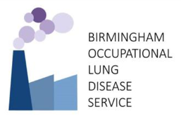

OCCUPATIONAL ASTHMA COURSE 28th and 29th April 2026
REGISTRATION FORM

Please complete this form and return to Vicky Moore e-mail: vicky.moore@uhcw.nhs.uk

Title
First Name
Surname
Job Title
Workplace
Address
Email address
Telephone number

Registration including lunch and refreshments during the course (delete as appropriate)

Y / N Non-ARTP member course rate (£450)
Y / N ARTP member course rate (£395) ARTP registration number (required):
Y / N Trainee course rate (£395)

Dietary Requirements:

PAYMENT INFORMATION

Payment is via an online link: https://hospitalcharity.org/products/occupational-asthma-course

Unfortunately, we are unable to issue invoices therefore payment is via credit/debit card only.

Please tell us how you heard about the course

Cancellation Policy
All cancellations must be received in writing by post or email
Cancellations before 10th April 2026 will be subject to a £20 administration charge; no refunds after 10th April 2026 will be given.

